Shabbos Stories for
Parshas Bereishis 5783
Volume 14, Issue 6 – 27 Tishrei 5783/October 22, 2022
Printed L’illuy nishmas Nechama bas R’ Noach, a”h

For a free subscription, please forward your request to keren18@juno.com
Past stories can be found on the website ShabbosStories.com

Noticing the Seamstress

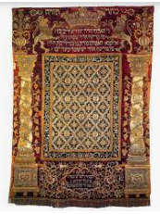

“Yes, it’s very beautiful. It is a kavod for the aron kodesh and a kavod for the Sifrei Torah.”
A talmid had accompanied Rav Shlomo Freifeld, rosh yeshivah of Yeshivah Sh’or Yoshuv in Far Rockaway, to purchase a new paroches for the yeshivah’s aron kodesh. They had found a beautiful antique paroches that had been made in India many years ago.
“It’s beautiful, but it does need some mending. Let’s ask the storeowner about having it fixed.”
The man assured them that his seamstress was outstanding and would have the paroches looking as good as new. Sometime later, Rav Freifeld and his talmid returned to the store to pick up the paroches. Rav Freifeld was very pleased.
“It’s beautiful,” he told the storeowner. “I am so pleased. Would you allow me to go to the back of the store so that I can thank the seamstress?”
The man was touched that this great rabbi would want to take the time for this. He led him to the back of the store, where Rav Freifeld warmly thanked the seamstress for her outstanding work.
Many years later, after Rav Freifeld passed away, the seamstress told his son-in-law, Rav Naftoli Jaeger, “For forty years I worked in the back of the store making things beautiful, but no one ever noticed. But when your father-in-law picked up the paroches, he insisted on coming to the back of the store to thank me personally, telling me how magnificent my work was and how beautiful the paroches would look when it hung on the yeshivah’s aron kodesh.”
Great people make sure to thank those to whom they owe appreciation.

Reprinted from the Parshas Ki Savo 5782 edition of At the ArtScroll Shabbos Table.

The Real Reason for the Government’s Seizure
Of the Town’s Shul

A contingent of government officials came to Rimanov to find a warehouse for the army's food and supplies. After combing the city, the only place they came up with was the local Shul.
When the heads of the Kehila heard, they ran to R’ Mendele of Rimanov to ask him what to do. One person stood up and said that as soon as they told the officials that the roof leaks and all their supplies would be ruined, they would change their minds and not use the Shul as a storehouse.
Everyone agreed that this seemed a good plan of action. R’ Mendele, however, heard this and said they were sorely mistaken. In fact, he said, it was because of the leaky roof that this Gezeira had befallen them.
“If we don't actively take care of our own Shul, and degrade its honor by allowing the roof to leak, what do you expect of the non-Jews? Go fix the roof right away and everything will be alright.”

Reprinted from the Parshas Nitzavim 5782 email of Rabbi Jonathan Gewirtz’s Migdal Ohr.
Amazing Both the Ponovez Rosh Yeshiva and the
Chazon Ish in Bnei Brak!
By Rabbi Mordechai Levin

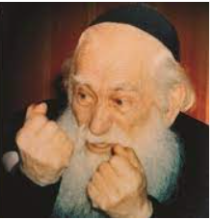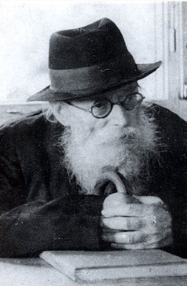
Rav Yosef Shlomo Kahaneman and the Chazon Ish of blessed memories

Rav Shlomo Reichenberg recounted being sent to a Kibbutz after arriving in Israel in 1945 as a Holocaust survivor. He requested to be transferred to a Yeshiva, and was sent to check out two, Ponovezh in Bnei Brak and Kol Torah in Jerusalem. He made his way to the one-story building that was Ponovezh Yeshiva at the time, and as he entered was stopped by a man who inquired whom he was looking for.
He responded “Rav Kahaneman”.
“That is me”.
A conversation ensued. He explained that he had arrived in Israel from the Bergen Belsen concentration camp and was now looking for a Yeshiva. He had been in Veitzin Yeshiva near Budapest before the war. Rav Yosef Shlomo Kahaneman (1886-1969) asked if he remembered anything that he had once learned. Rav Shlomo remembers that he tensed up, afraid that he’d need to pass a test in order to be accepted into the Yeshiva. He said, “Ask me a question”.
He was asked which was the last mesechta he learned, and he answered “Chulin”. He was then asked if he remembered an argument between Rashi and Tosafos in Chulin. He told him one.
Rav Kahaneman kissed him on his forehead and walked him through the streets of Bnei Brak until they reached a small building, the home of the Chazon Ish (Rabbi Avraham Yeshaya Karelitz, 1878-1953)! Rav Kahaneman became overcome with emotion, and told the Chazon Ish how a young concentration camp survivor could still say over a “Machlokes Rashi and Tosafos in Chulin”!
“Greatness of Torah”, he exclaimed, “If a concentration camp can’t make a Jew forget Torah, then Torah will never be forgotten”! The Chazon Ish proceeded to spend two hours with the young man, listening to details of life in the camp. Upon finishing, the Chazon Ish said to young Shlomo, “This is your new home. The door is always open for you”. (Peninei Chein Al HaTorah, Lipschutz)

Reprinted from the Parshas Nitzavim 5782 email of Reb Mendel Berlin’s Torah Sweets Weekly.

The Torah Concentration of Rav Chaim Kanievsky

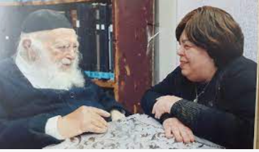
Rav Chaim Kanievsky and his Rebbetzin Batsheva Kanievsky

Rav Chaim Kanievsky asked the Rebbetzin that whenever she left the apartment, she should lock the door. Many people sought his audience and it disturbed his learning. This was why a specific time was allotted for Kabbolas Ha’Khal, when he would listen, speak and offer blessings to those who came to see him.
One time, the Rebbetzin forgot to lock the door. Rav Chaim noticed that it was unlocked, so he locked it. The Rebbetzin returned home and saw that the door was locked. Since she had not locked it originally, she did not have a key to open the door.
It was a sweltering, hot day in Bnei Brak. The Rebbetzin began to knock, hoping that her husband would hear and let her in. Twenty minutes of knocking and calling passed until finally Rav Chaim opened the door and said, “The Rebbetzin is not home,” and promptly closed the door! The Rebbetzin immediately called out, “Chaim, it’s me!”
The story was publicized. When one of his aides showed him the written version of the story, Rav Chaim wept. “I do not remember the incident, but it is possible that it happened,” he said.
What occupied Rav Chaim that could divert his attention from everything? In another incident, one of Rav Chaim’s neighbors, himself an outstanding talmid chacham, observed that Rav Chaim was just not himself. He appeared distressed and frustrated.
Obviously, such feelings can take a toll o n a person’s health. The neighbor asked the Rebbetzin what was bothering Rav Chaim; how could he alleviate some of his distress? The Rebbetzin replied, “My dear Rav… two weeks have passed that Rav Chaim has been troubled by a question that he has on the Rambam, Hilchos Meilah. If you can give him an answer, all will be b’seder.”

Reprinted from the Parshas Nitzavim 5782 email of Rabbi A.L. Scheinbaum’s Peninim on the Torah

We Are Not in Control

A Jew does not despair. He has no right to give up hope, because it is not his to give up on. It all comes from Hashem. Horav Yaakov Galinsky, zl, relates how he spent World War II and its aftermath in the frozen tundra of Siberia. Following the Ribentrop/Molotov treaty, Lithuania remained a free state, until the Russians conquered and took it over.
The yeshivah students, consisting primarily of Yeshivas Novoradok, were rounded up and placed in cattle cars for the ten-day train journey to Siberia. The Russians did not permit the hapless Jews to exit the train to address their basic, personal needs. They were locked in like caged animals for ten days.
They spent fifteen years at hard labor in Siberia. These students were very down; having to leave their Torah studies for slave labor in the coldest place on earth. How envious they were of the students who were able to escape from the clutches of the Russian soldiers; until they discovered that they had fallen into the hands of the Germans who forthwith included them in their final solution.
In other words, what they thought was their disaster, was instead their ticket to salvation. Rav Galinsky relates that when he arrived in Eretz Yisrael he was a broken person, all alone in the world, his family having been murdered by the Nazis. He was told to go to speak with the Chazon Ish, zl, to develop some perspective on the past and engender hope for the future.

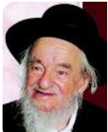
Rav Yaakov Galinsky

After pouring out his heart to the saintly gadol hador, pre-eminent leader of the generation, the Chazon Ish replied, “Do you have a right to despair? Does the world belong to you? The world belongs to Hashem, and as long as He is the Baalim, Owner, of the world, you have no right to give up hope.”
We place our trust in Him with the knowledge that whatever takes place in our lives is orchestrated by the Almighty for a reason. Giving up is not an option, because we are not in charge; we are not in control.

Reprinted from the Parshas Nitzavim 5782 email of Rabbi A.L. Scheinbaum’s Peninim on the Torah
A Unique Love for
Helping Torah Students

We must study His Torah for its sake. Love means to care only for the subject of one’s love – not for any other reason. One who studies Torah for ulterior motives will not come to love Hashem. We love G-d as a result of our love/study of the Torah. The two go hand in hand.
Horav Reuven Karlinstein, zl, relates a story that he heard from the son of Horav Shmaryahu Greineman, zl, who never left the side of the Chazon Ish, zl. The grandfather of the Chazon Ish’s grandfather (his great—great grandfather) was the famed Baal ha Pardes and Rav of Konigsberg. He was a contemporary of the Gaon, zl, m’Vilna and often corresponded with him and also with Horav Yonasan Eibyshutz, zl.

He Made a Suggestion for a Worthy Successor
Shortly before his passing, the members of his community asked him, “Who will be your successor? Who will be our Rav?” He instructed them to travel to a certain community and speak with its Rav concerning assuming the rabbinic leadership of Konigsberg.
They travelled to this city and, after meeting with the Rav, offered him the rabbanus of Konigsberg. He then asked, “Is there a yeshivah in your community?”
“But of course, a nice yeshivah with students who spend their days and nights learning.”
He asked a few more questions before agreeing to accept their offer. He insisted, however, that they remain in the city for Shabbos so that he can address his community and offer the proper leave-taking of them. They agreed to spend Shabbos.

Surprisingly, He Retracts His
Acceptance of the Rabbinical Post
Friday morning, the Rav summoned them to his house and said, “I have changed my mind. I will not be joining your community.”
The men were floored. They thought that everything was settled to each one’s satisfaction. “What is wrong?” they asked. “The Rav had agreed. Why is his honor changing his mind?”
He explained. “The following morning after I agreed to go with you, I noticed my Rebbetzin weeping copious tears. I asked what was wrong. She explained that every week she washes the clothes of the talmidim, students, of our yeshivah. (In those days it was a strenuous and difficult job, consisting of heating water and scrubbing the clothes in the burning hot water. There were many students in the yeshivah. Understandably, she was busy with this every day.)
The heads of the community interjected, “We have a group of women whose job it is to wash the students’ clothes. The Rebbetzin will not have to trouble herself anymore.”
“You do not seem to understand,” the Rav explained. “This is the Rebbetzin’s life. With each garment that she washes, dries and smooths out, she partners with the students’ learning. This is her Torah learning. My Rebbetzin said, ‘If you take this from me, I have no reason to live. Without my partnering with the students in their Torah learning, what value is there to my life?’
“How can I deprive my Rebbetzin of life?” The Chazon Ish would often relate this story, to show the love for Torah evinced by the previous generations.

Reprinted from the Parshas Nitzavim 5782 email of Rabbi A.L. Scheinbaum’s Peninim on the Torah

The Blessing that
Cured the Queen
By Lazer Brody

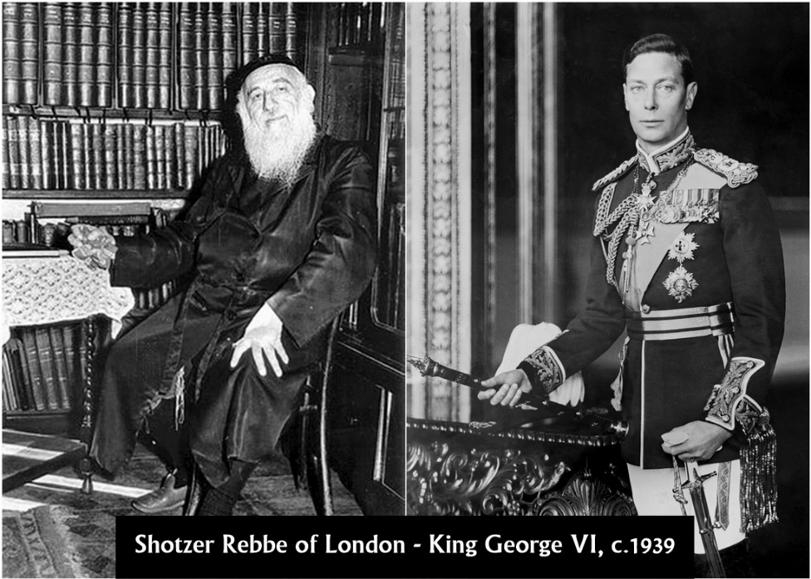

Here is an amazing true story that few people are aware of. It’s also a secret that even fewer people knew. And, it’s the unforgettable account of when the Shotzer Rebbe of London met face-to-face with King George VI. This was the momentous meeting that saved the life of the future Queen Elizabeth.

Epilepsy and the Royal Family
Epilepsy was in the genes of the British royal family. Queen Elizabeth’s uncle Prince John, the youngest son of King George V, died at age 13 from a severe seizure. That was in 1918.

Let’s fast-forward to 1939. Now, King George VI was deathly afraid that his 13-year-old daughter Elizabeth would meet the same fate as his brother Prince John.

The Kindertransport
That same year, the Jewish Agency was organizing the famous Kindertransport (German for “children’s transport”). This was the rescue effort of children from Nazi-controlled territory. It took place during the nine months prior to the outbreak of the World War II in September of 1939. The United Kingdom took in nearly 10,000 predominantly Jewish children from Germany, Austria, Czechoslovakia and Poland. This initiative encountered strong resistance from certain British circles.
The Chief Rabbi of England at the time was Rabbi Joseph Herman Hertz. He decided to intercede on behalf of the Kindertransport, so he visited King George VI together with the holy tzaddik, The Shotzer Rebbe of London, Grand Rabbi Shalom Moscowitz, osb”m.

The Rebbe’s Blessing
King George VI never saw such an illuminated countenance as that of the Shotzer Rebbe. He asked for a blessing for his daughter, who was 13 at the time, and suffering from epileptic seizures. “Please, might the Rebbe pray that my daughter will live.”
The Rebbe answered unequivocally, “If Your Majesty will assure that the Kindertransport is approved, and thereby save Jewish children, then undoubtedly measure for measure, the princess will not only live, but her ailment will disappear altogether.”
The King was deeply moved. The Kindertransport began immediately and the princess – later to be Queen Elizabeth II who passed away at the ripe old age of 96 on September 8, 2022 – was miraculously cured immediately.
Rabbi Lazer Brody’s teacher and spiritual guide, Grand Rabbi Naftali Moscowitz shlit’a, aka the “Melitzer Rebbe of Ashdod,” is the grandson of The Shotzer Rebbe of London, Grand Rabbi Shalom Moscowitz, osb”m. Recently, Rabbi Lazer visited the holy gravesite of the Shotzer Rebbe at the Adath Yisroel Cemetery in Enfield, outside of London, and prayed for all of our readers, subscribers and supporters.

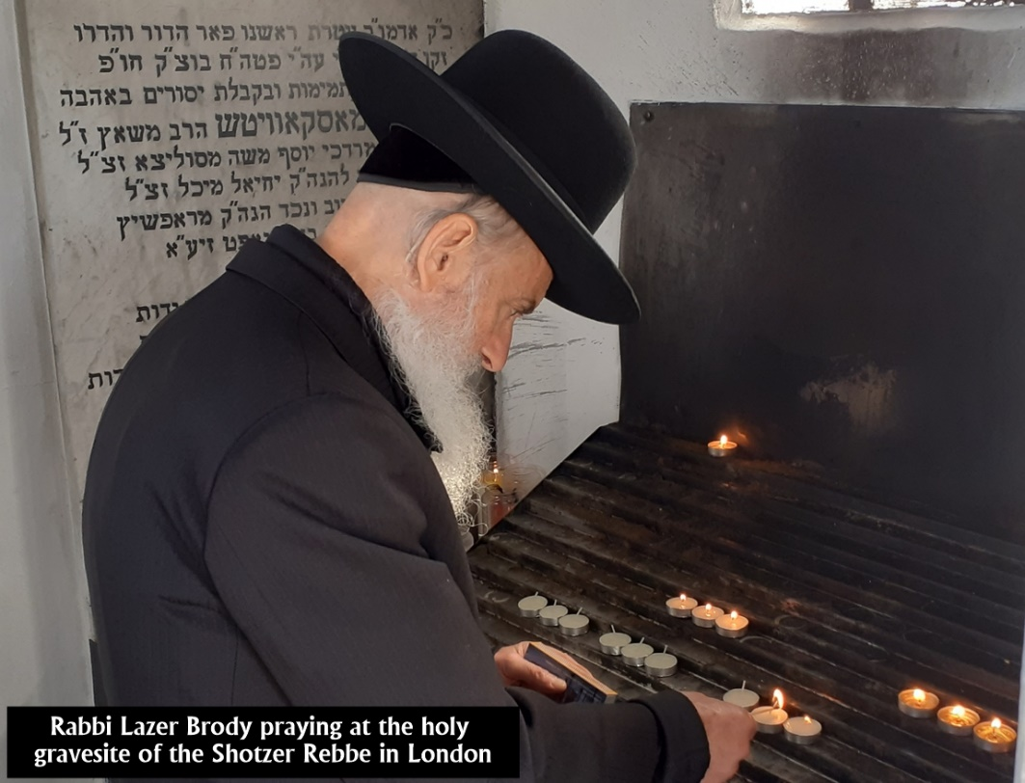

Reprinted from the September 19, 2022 website of emunabeams.com
Ben Adam LeMakom

Photo of Tel Aviv street sign in honor Rav Saadia Gaon

Rabbi David Ashear told a story in Living Emunah 2 about Rav Saadia Gaon, who would make a point to seclude himself in a private room for 20 minutes daily. One day, a student, overcome with curiosity, went into his rabbi’s private space and hid in a closet. The rabbi came in and proceeded to lower himself to the floor, crying, “Chatati, aviti, pashati lefanecha – I have sinned before You….” The student could not understand why this great rabbi could possibly cry for forgiveness and do such an intense teshuvah daily.
The student approached his rabbi and confessed to having watched him. “Why do you beg Hashem for forgiveness every day in such an intense fashion?” He asked.
Rav Saadia explained that once on his travels, he stopped at the home of a very kindhearted Jew. The host was generous and hospitable, offering the rabbi meals and a room. When morning came, Rav Saadia warmly thanked him and went on his way.
Suddenly, a few minutes later, Rav Saadia saw his host running after him, throwing himself on the floor and begging the Rav for forgiveness. The rabbi inquired, asking why he was so upset when the host provided such generous hospitality. The host cried, “I did not know you were the Great Rav Saadia Gaon. I would have shown you so much more respect and honor.”

The Rabbi explained to his student, “Each day, I find out something new about the greatness of Hashem, and I become filled with guilt. I would have served Hashem with much more respect and care if I had known. So each day, I have to beg Hashem for forgiveness, for not treating Him properly the day before.”

Reprinted from the Parashat Vayelech 5783 email of Jack E. Rahmey based on the Torah teachings of Rabbi Amram Sananes.

Will Dad Want Me?

Every day in the Amidah, we recite a blessing about teshuvah. The prayer ends with “Hashem Harotzeh b’teshuvah—Hashem desires repentance.” We repeat these words so often during the year that they may lose their impact. These words do not mean that the Almighty will just accept our repentance but that He wants our repentance. His desire for us to return to Him is so enormous that as long as we make even a minimal effort, He will be waiting there to take us back.
Rabbi Yissochar Frand told a story about a boy who finished high school and told his parents he wanted to see the world, which is quite typical of youth. His father told him, “No, I want you to start college.” The boy would not accept his father’s advice. “I need to see what the rest of the world is like. I want to travel.” The father told his son, “If you leave, don’t bother coming back. You can start college now, or leave this house and keep going because you will never be welcome again.” The boy decided to leave anyway.

The Boy Became Homesick
He left his home in Maryland and began hitchhiking across America. He did odd jobs here and there to keep himself going. After some time, the boy became homesick. He missed his parents. He missed home. He started hitchhiking back to the east coast. He got as far as Iowa, sat down on a curb, and wrote a letter home.
“Dear Mom, I’m tired. I’m hungry. I’m lonely. I want to come home. But I don’t know if Dad will let me home. Mom, the train passes an apple tree near the tracks by our house. If Dad lets me come back, please tie a white cloth around a branch of that tree. I’ll get on the train, look for the apple tree, and check. If Dad still feels the same way and there’s no white cloth, I’ll know I can’t come home.”
The boy boarded a passenger train and started heading home. As the train approached the tree, he became terribly nervous. Would there be a cloth there? As it came closer and closer, he turned to the man sitting next to him on the train and said, “Please do me a favor. We’re going to pass a farm with an apple tree right near the tracks. I am going to close my eyes. Please tell me if white fabric is wrapped around a branch on that tree. I’m too nervous to look myself.”
He was so scared that it wouldn’t be there. He sat with his eyes tightly shut as the train passed the tree. The man said, “Son, there is a white cloth around every branch on that tree.” The father clearly could not wait for his son to come home.
This is what “Hashem desires repentance” means. Hashem wants us back passionately, just like any father who may have had disagreements with his son, if not more.

Reprinted from the Parashat Vayelech 5783 email of Jack E. Rahmey based on the Torah teachings of Rabbi Amram Sananes.

Wearing the Watch
On One’s Left Hand

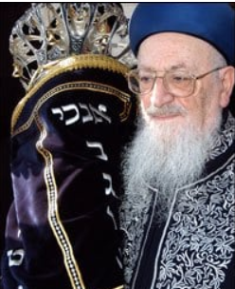

Most people wear a watch on their left hand, so that it’s easy to adjust with the right hand, if they are righthanded. However, Rav Mordechai Eliyahu, zt”l, would always wear his watch on his right hand, even though he was right-handed.
Once, he was asked why he did that, and he responded, “I do it so that I do not insult people. Sometimes, you can be speaking in public, and somebody looks at his watch. What does that make the one who is speaking think? He thinks that his words aren’t interesting to him, even though he may be looking at his watch for another reason entirely. Sometimes looking at your watch can insult someone who is talking to you, as he’s likely to think that you’re waiting for him to stop talking.
“Therefore, I wear my watch on my right wrist, with the face turned inwards towards my body. That way, I can look at my watch without insulting the person who is talking to me, not even in the slightest!”
Rav Eliyahu also said that doing this also gave him an extra minute every day, when he would normally have to move the watch from his left hand to his right hand before Davening, when it was time to put on his Tefilin. Even such a short amount of time could add up to a long time over a long period, and that time could be used to do more important things!

Reprinted from the Parshas Vayelech 5783 email of Rabbi Yehuda Winzelberg’s Torah U’Tefilah
Hearing the Smile

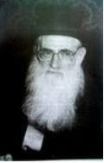

The Talmidim of Rav Chaim Friedlander, zt”l, noticed that he had a warm smile on his face, even when he spoke with someone on the phone.
A student once asked him, “Rebbe, the person on the other end of the line can’t see your smile. Why do you bother to smile when you speak with him?”
Rav Friedlander responded, “Even though the listener may not be able to see my smile, he can certainly hear my smile.” He explained that a happy expression on one’s face when he speaks on the phone will be heard through his voice!

Reprinted from the Parshas Vayelech 5783 email of Rabbi Yehuda Winzelberg’s Torah U’Tefilah

